**Phase -2 Org Setup & Configuration :**

**1. Salesforce Edition (Developer Org)**

1. Go to Salesforce Developer Edition Signup.
2. Fill in your details: Name, Email, Company, Country.
3. Click **Sign me up**.
4. Verify your email and log in.
5. Check that your org has:
   * Custom Object creation
   * Lightning App Builder
   * Process Automation (Flows, Approval Processes)
   * Reports & Dashboards

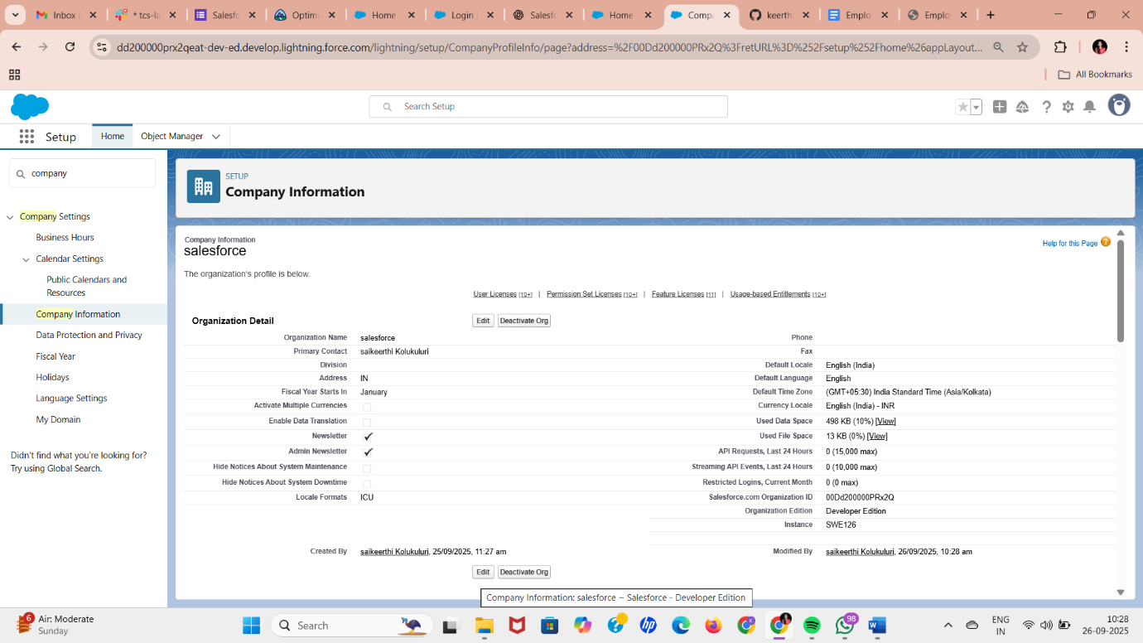

**2. Company Profile Setup**

1. Click **Setup** (⚙️ icon) → **Setup**.
2. In the Quick Find box, search **Company Information** → click it.
3. Click **Edit** and fill in:
   * **Company Name:** e.g., “ABC Pvt Ltd”
   * **Primary Contact:** your email or HR email
   * **Default Currency:** e.g., INR/USD
   * **Default Locale:** India/English
   * **Default Time Zone:** IST (GMT+5:30)
4. Click **Save**.

This ensures all records, reports, and notifications match the organization’s details.

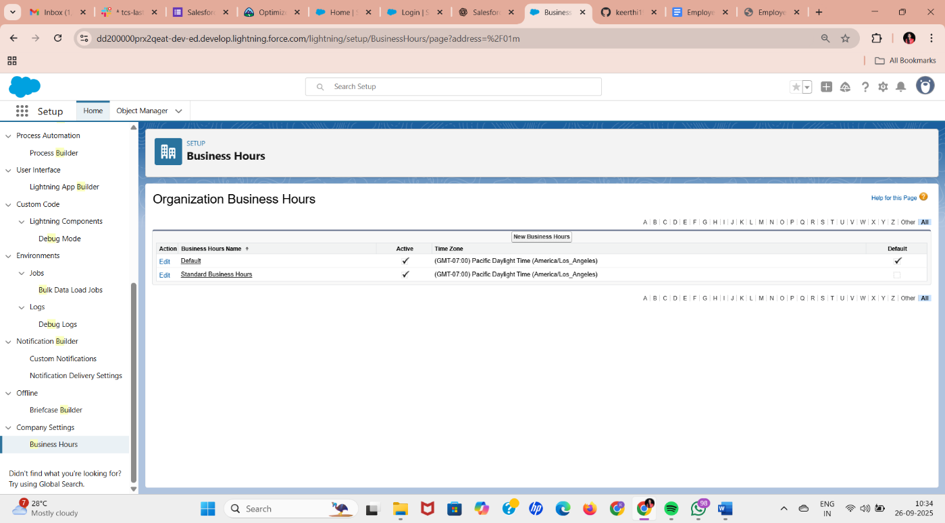

**3. Business Hours & Holidays**

**Business Hours:**

1. Setup → Quick Find → **Business Hours** → New Business Hours
2. Enter:
   * **Name:** e.g., “Standard Business Hours”
   * **Active:** Checked
   * **Start Time:** 09:00 AM
   * **End Time:** 06:00 PM
   * **Time Zone:** IST
3. Click **Save**

**Holidays:**

1. Setup → Quick Find → **Holidays** → New Holiday
2. Fill in:
   * **Holiday Name:** e.g., “Diwali”
   * **Holiday Type:** Public
   * **Start Date/End Date:** select correct dates
   * **Business Hours:** link to “Standard Business Hours”
3. Click **Save**

This ensures leave requests do not overlap with holidays.

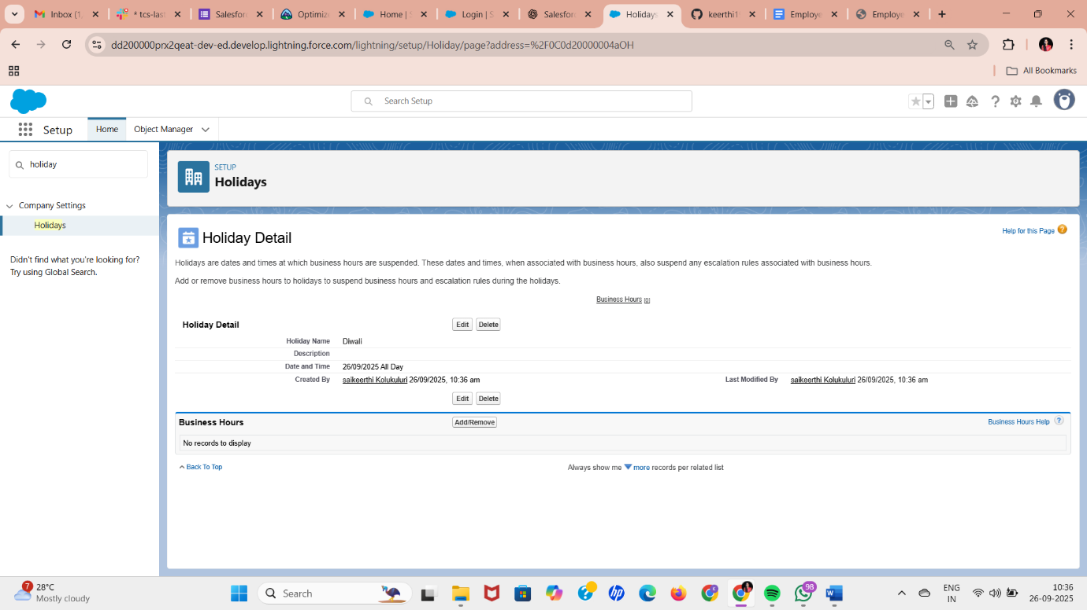

**4. Fiscal Year Settings *(Optional)***

1. Setup → Quick Find → **Fiscal Year**
2. Click **Standard Fiscal Year** → Next → Set **Start Month** (e.g., April for Indian FY)
3. Save settings

Helpful if leave accruals or reports are based on fiscal year.

**5. User Setup & Licenses**

1. Setup → Quick Find → **Users → Users → New User**
2. Create users for each role:
   * **Employee:**
     + First Name / Last Name
     + Email
     + Username (must be unique, e.g., employee1@abc.com)
     + Role: Employee
     + Profile: Standard User / Employee Profile
   * **Manager:**
     + Role: Manager
     + Profile: Manager Profile
   * **HR/Admin:**
     + Role: HR/Admin
     + Profile: System Administrator
3. Click **Save**

These users simulate different roles in the Leave Management App.

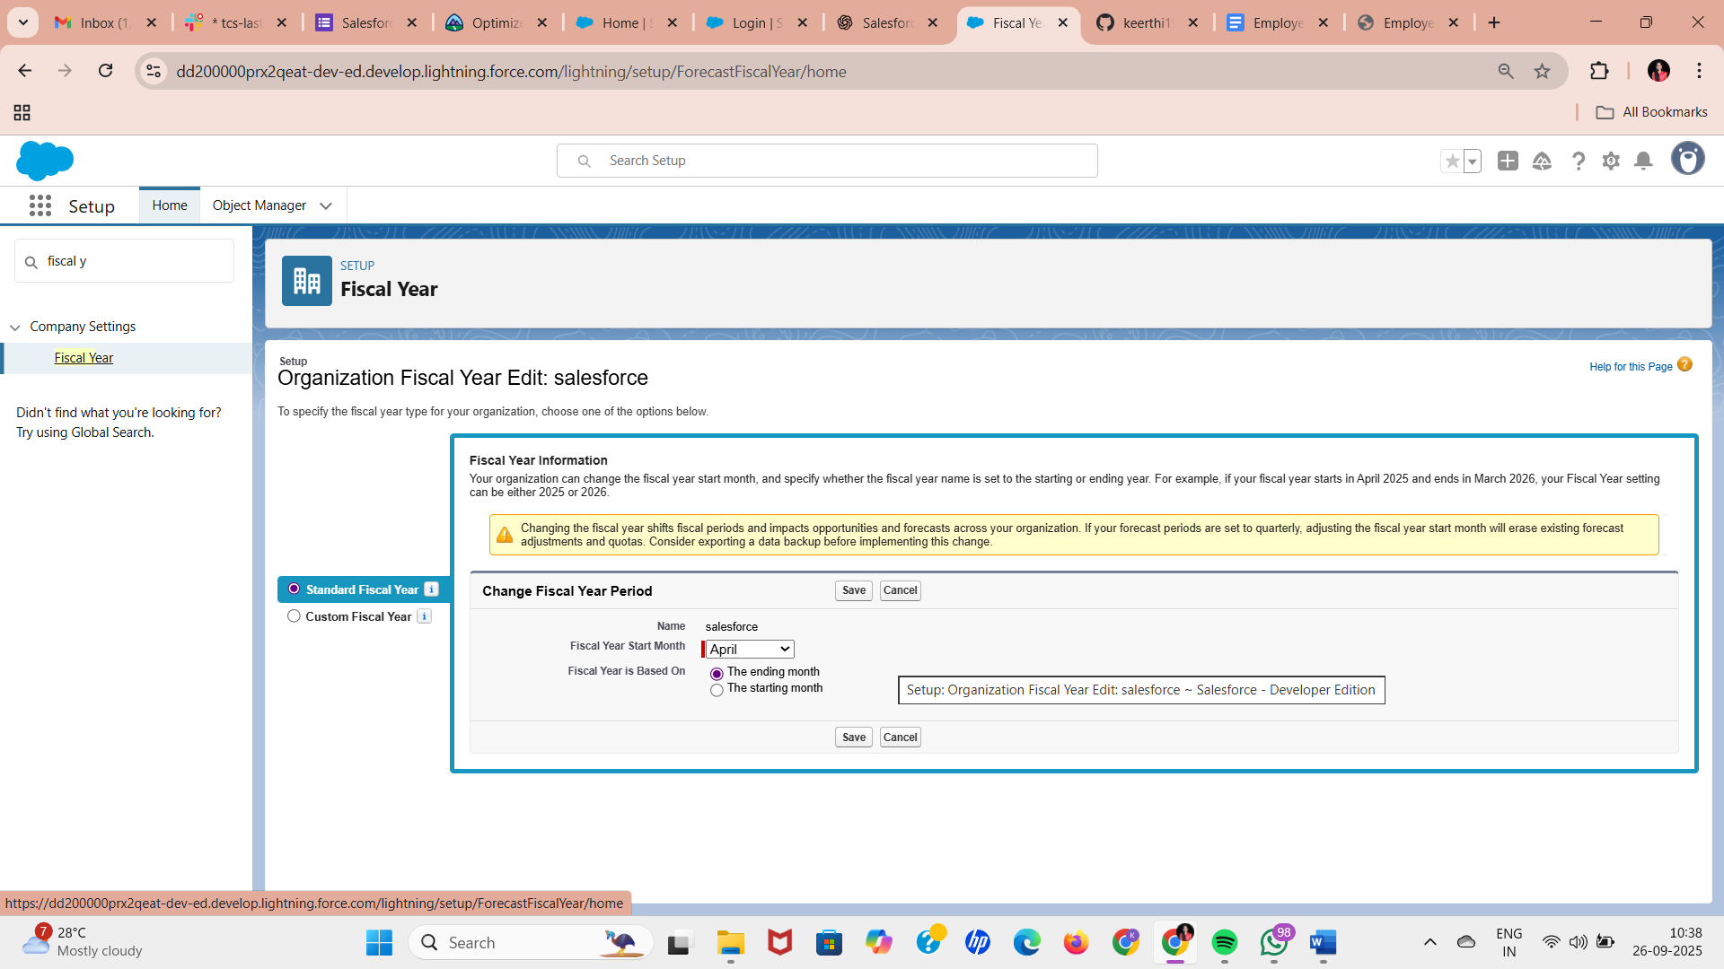

**6. Profiles**

1. Setup → Quick Find → **Profiles**
2. Edit or clone:
   * **Employee Profile:**
     + Object Settings → Leave Request → Create, Read, Edit (own only)
     + Employee can view own leave balance
   * **Manager Profile:**
     + Leave Request → Read/Edit for team members
     + Can approve/reject leave
   * **HR Profile:**
     + Full access to all leave objects and reports
3. Save each profile.

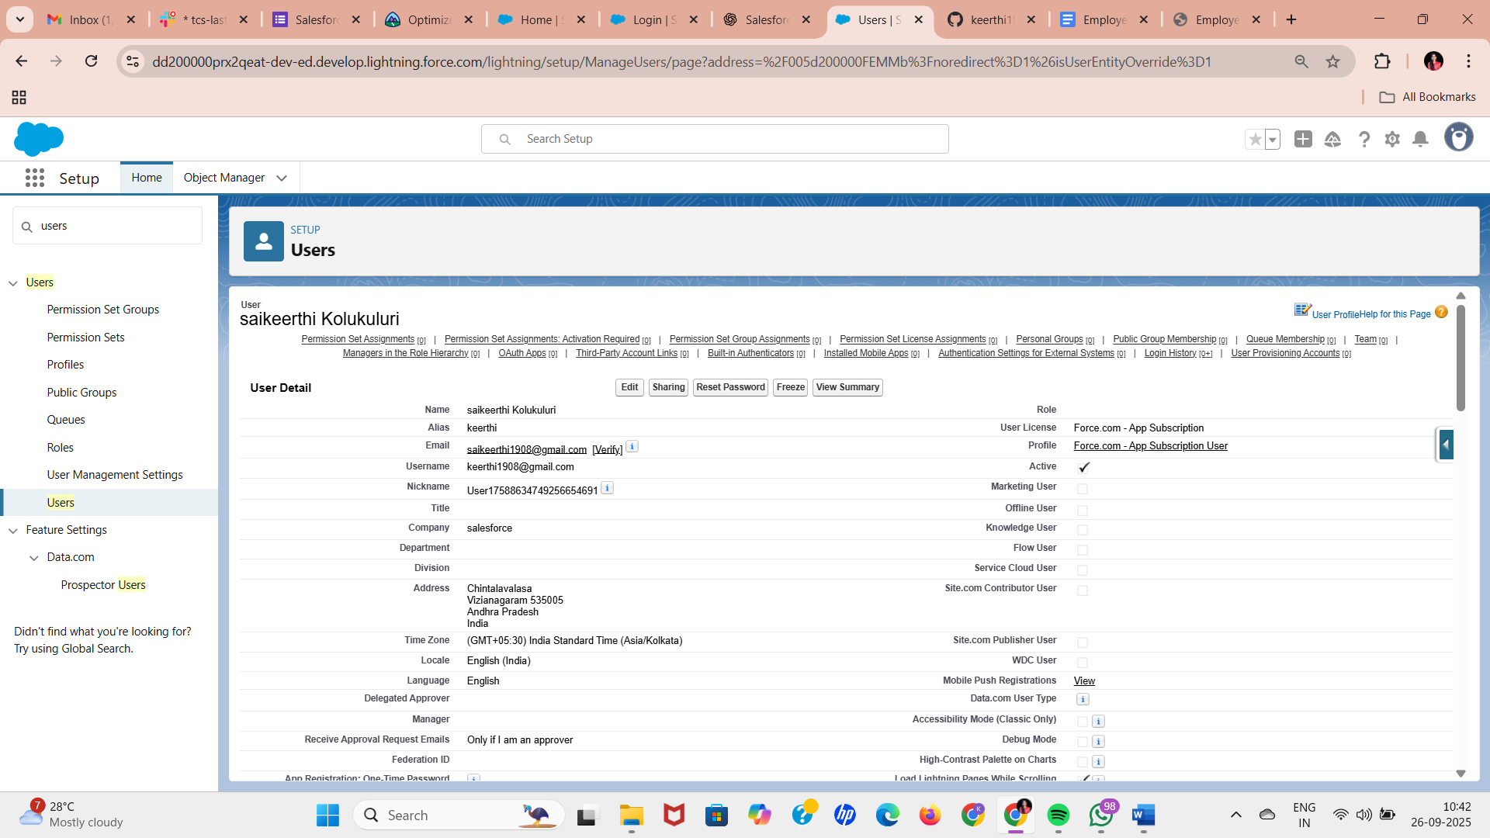

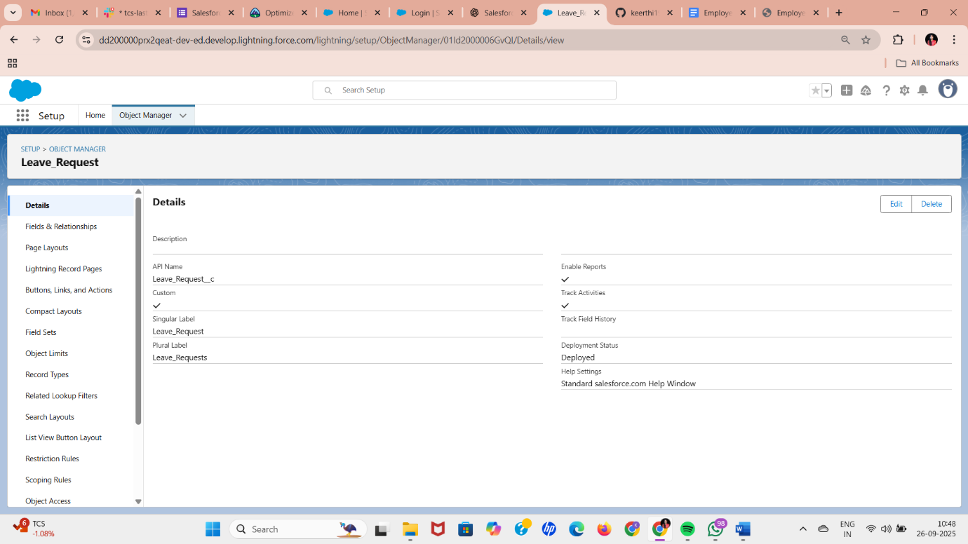

**7. Roles**

1. Setup → Quick Find → **Roles → Set Up Roles**
2. Click **Add Role** or **View Hierarchy**
3. Create hierarchy:
   * HR/Admin → Manager → Employee
4. Assign users to their respective roles
5. Save changes

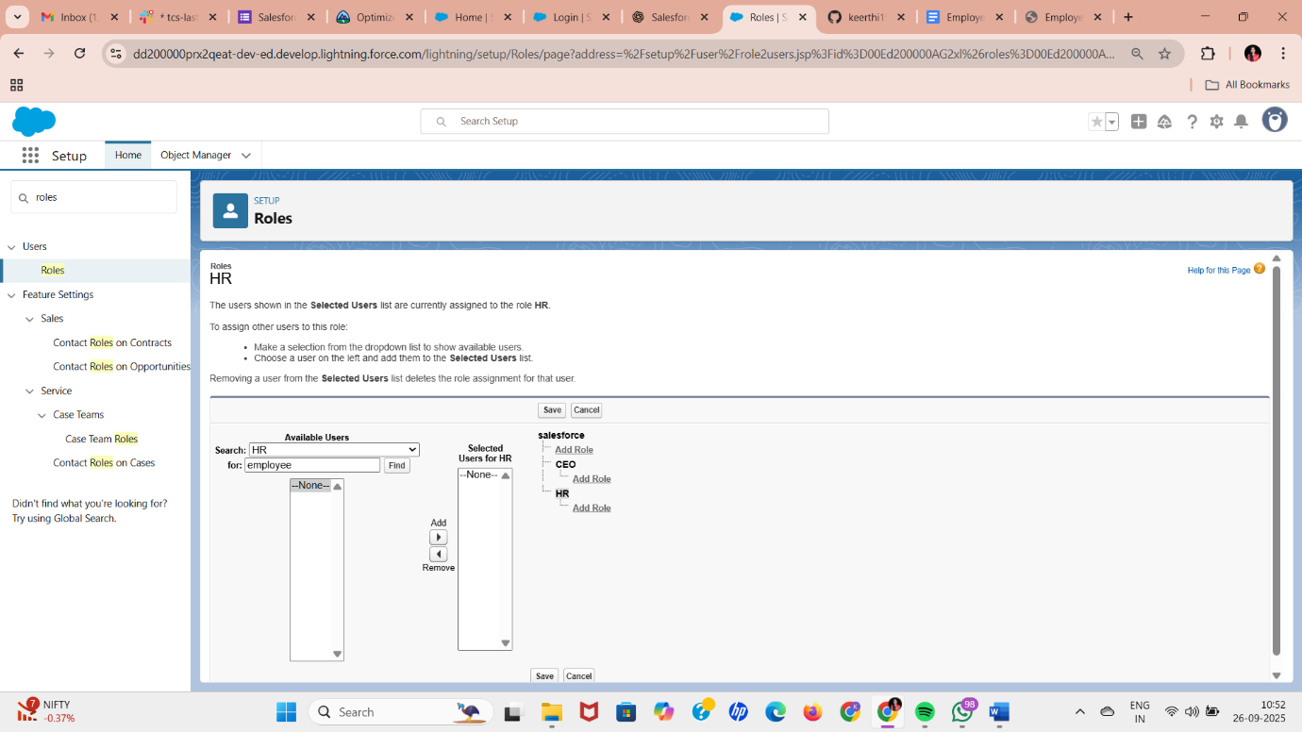

**8. Permission Sets**

1. Setup → Quick Find → **Permission Sets → New**
2. Name: e.g., “Leave Report Access”
3. License: None (or match user license)
4. Save
5. Add Object Permissions: Leave Request → Read/Edit as needed
6. Assign this permission set to employees or managers

**9. Organization-Wide Defaults (OWD)**

1. Setup → Quick Find → **Sharing Settings**
2. Scroll to **Leave Request** object → Edit
3. Default Internal Access → **Private**
4. Employee Object → Public Read Only for HR
5. Save

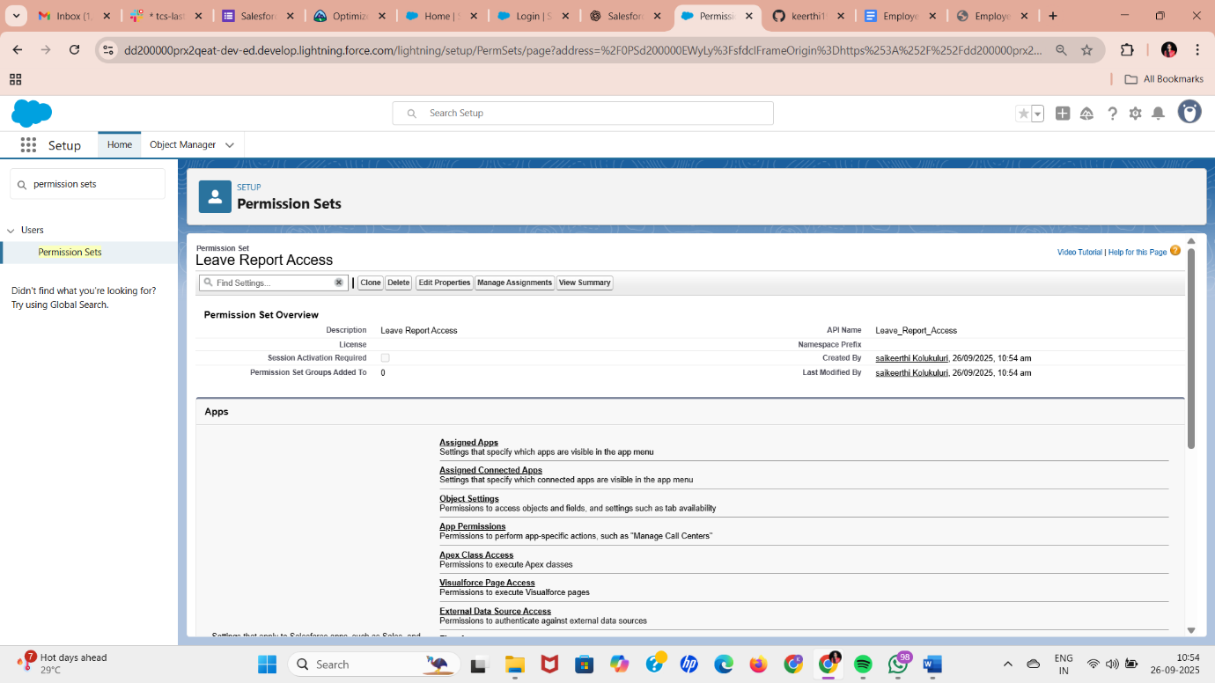

**10. Sharing Rules**

1. Setup → Quick Find → **Sharing Settings → New Sharing Rule**
2. Example Rule:
   * Rule Name: Manager Access to Team Leave
   * Based on: Role → Manager
   * Access Level: Read/Write
3. Save and Activate

Automatically shares leave requests with managers and HR.

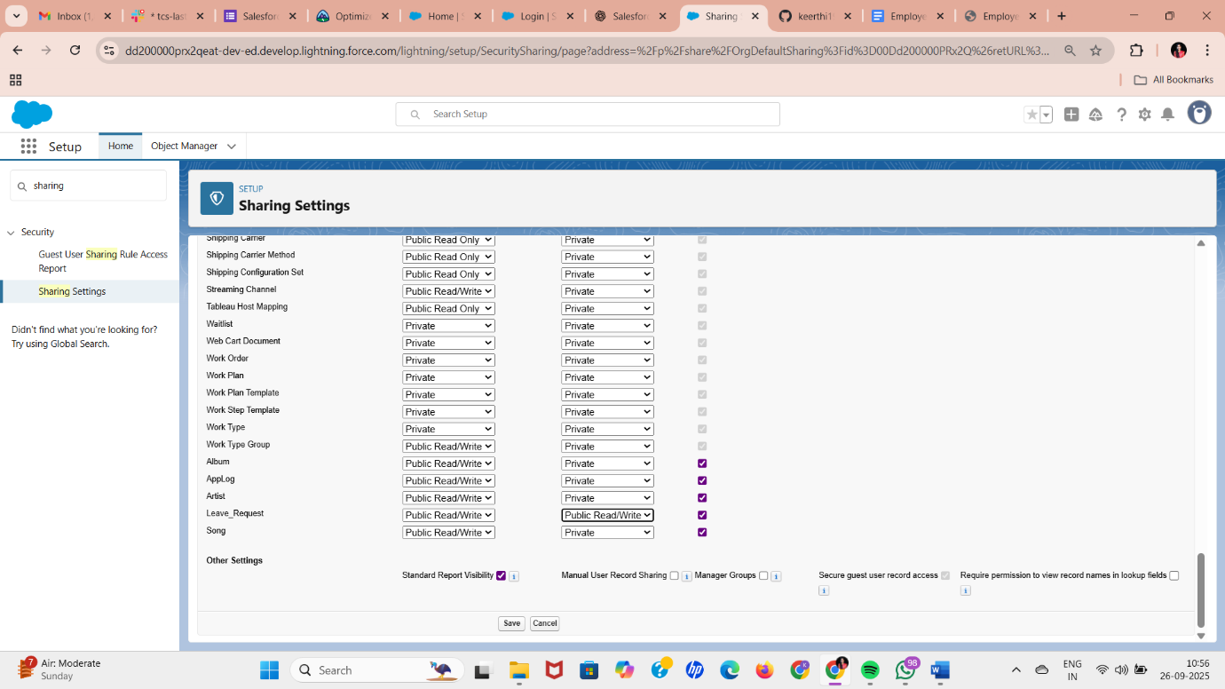

**11. Login Access Policies *(Optional)***

1. Setup → Quick Find → **Login Access Policies**
2. Set:
   * Session timeout (e.g., 30 minutes)
   * IP range restrictions if desired
3. Save

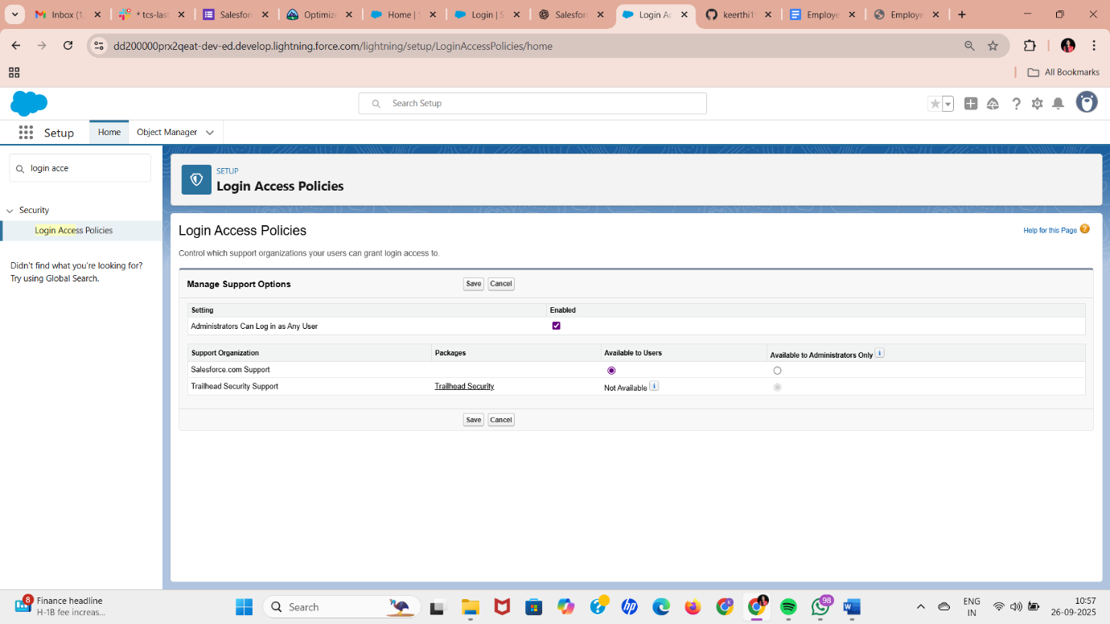

**12. Dev Org & Sandbox Usage**

* All development can be done in **Developer Org**.
* Optionally, create Sandbox if you want safe testing: Setup → Sandboxes → New Sandbox

**13. Deployment Basics**

* Changes will stay in Developer Org.
* For future deployment: use Change Sets or Salesforce DX (optional).